Lights in Alingsås 2004


Introduction
What is the workshop?
The sites
The Park
The Industrial Façade and the Garden
The New Bridge
The Old Spa Park
The Afzelli School
The Yard
English Deutsch
Intersection
Headed by Mario Rechsteiner/ELDA
Participants: José Alvares Correia/P, Henric Ericsson/S, Jenny Skufserud/S, Jan Stenberg/S, Katarina Vukoja/S, Linda Heller/D, Petra Steiner/D, Stella Kasparek/D, Susanne Stolz/D
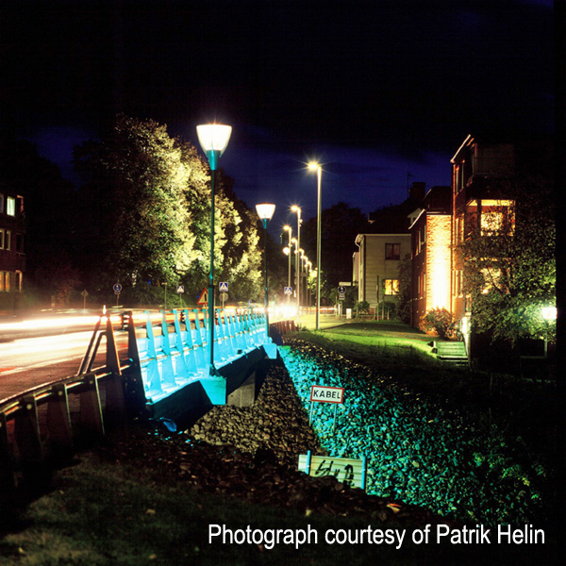
It is a place where a series of opposites meet. Organic nature - silence and slow movements. And the main road - the noise and the speed of traffic creating a third element that intersects at the bridge - the main pulse of the area.
The project site is one of the main entrances to the town. The group wanted to create a welcoming message, while at the same time addressing the different aspects of the junction.
Click on a thumbnail to view the full picture.
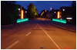 | 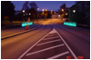 | 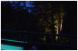 | 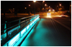 | 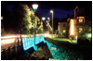
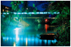 |  | 